Project Planning Phase
Project Planning Template (Product Backlog, Sprint Planning, Stories, Story points)

Date | 5 July 2026
Team ID
Project Name | OptiCrop: Smart Agricultural Production Optimization Engine
Maximum Marks | 5 Marks

Product Backlog, Sprint Schedule, and Estimation (4 Marks)
Use the below template to create product backlog and sprint schedule
Sprint | Functional Requirement (Epic) | User Story Number | User Story / Task | Story Points | Priority | Team Members
Sprint-1 | User Interface | USN-1 | Design responsive home page with project information | 2 | High | Member-1
Sprint-1 | Crop Recommendation | USN-2 | As a farmer, I can enter soil nutrients (N, P, K), temperature, humidity, pH and rainfall | 3 | High | Member-2
Sprint-1 | Crop Recommendation | USN-3 | As a farmer, I can receive the best crop recommendation based on input parameters | 5 | High | Member-2
Sprint-2 | Crop Suitability | USN-4 | As a farmer, I can check whether my preferred crop is suitable for my field | 3 | High | Member-3
Sprint-2 | Machine Learning Model | USN-5 | Train and integrate the crop prediction model using Scikit-learn | 5 | High | Member-2
Sprint-2 | Backend Integration | USN-6 | Connect Flask backend with frontend forms | 3 | High | Member-1
Sprint-3 | Dashboard | USN-7 | Display recommendation results with crop details | 3 | Medium | Member-1
Sprint-3 | Data Visualization | USN-8 | Show agricultural insights and dataset statistics | 3 | Medium | Member-3
Sprint-3 | Testing | USN-9 | Perform unit testing and validate prediction accuracy | 2 | High | Member-4
Sprint-4 | Deployment | USN-10 | Deploy application on Render/Heroku | 3 | Medium | Member-4
Sprint-4 | Documentation | USN-11 | Prepare project report, user manual and presentation | 2 | High | Member-4
Project Tracker, Velocity & Burndown Chart: (4 Marks)
Sprint | Total Story Points | Duration | Sprint Start Date | Sprint End Date (Planned) | Story Points Completed (as on Planned End Date) | Sprint Release Date (Actual)
Sprint-1 | 13 | 7 Days | 5 June 2026 | 11 June 2026 | 13 | 11 June 2026
Sprint-2 | 11 | 7 Days | 12 June 2026 | 18 June 2026 | 11 | 18 June 2026
Sprint-3 | 8 | 7 Days | 19 June 2026 | 27 June 2026 | 8 | 27 June 2026
Sprint-4 | 5 | 7 Days | 28 June 2026 | 04 July 2026 | 5 | 04 July 2026

Velocity:
Imagine we have a 10-day sprint duration, and the velocity of the team is 20 (points per sprint). Let’s calculate the team’s average velocity (AV) per iteration unit (story points per day)
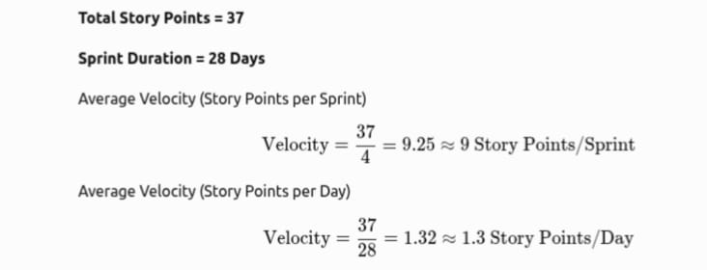

Burndown Chart:
A burn down chart is a graphical representation of work left to do versus time. It is often used in agile software development methodologies such as Scrum. However, burn down charts can be applied to any project containing measurable progress over time.

